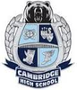
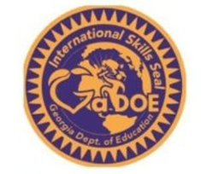
International Focus Courses for the
International Skills Diploma Seal

To be awarded the International Skills Diploma Seal, students need to complete coursework in the following areas (8 credits total)
- World Languages (at least three credits in the same world language and/or ESOL earned in high school. High School credits earned in middle school do not count.)
- International Focus (at least four credits in courses determined to have an international focus, such as international economics, world/non—U.S. history, world geography, etc.)

Cambridge courses from the Georgia Department of Education approved list:
CTAE:
- Marketing Principles (08.47400)
- Legal Environment of Business (06.41500)

English Language Arts:
- AP English Literature (23.06500)
- Contemporary Literature and Composition (semester class=1/2 credit) (23.06600)
- World Literature (23.06300)
Social Studies:
- AP Comparative Government and Politics (semester class=½ credit) (45.05300)
- AP European History (45.08400)
- AP Human Geography (45.07700)
- AP Macroeconomics (semester class=½ credit) (45.06200)
- AP Microeconomics (semester class=½ credit) (45.06300)
- AP Psychology (45.01600)
- AP World History (45.08110)
- Economics (semester class=½ credit) (45.06100)
- Sociology (semester class=½ credit) (45.03100)
- International Affairs (semester class=½ credit) (45.09100)
- World History (45.08300)
- World Geography (semester class=½ credit) (45.07110)
- Current Issues (semester class=½ credit) (45.01200)

Fine Arts:
- AP Art History (50.09210)

Science:
- AP Environmental Science (26.06200)
- Environmental Science (26.06110)

