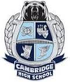
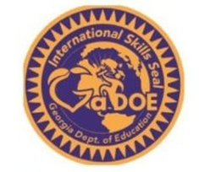

International Focus Courses for the International Skills Diploma Seal
To be awarded the International Skills Diploma Seal, students need to complete coursework in the following areas (8 credits total)
- World Languages (at least three credits in the same world language and/or ESOL)
- International Focus (at least four credits in courses determined to have an international focus, such as international economics, world/non—U.S. history, world geography, etc.)
Cambridge courses from the Georgia Department of Education approved list:
CTAE:
Environmental Science
AP Environmental Science
∙ Legal Environment of Business (BCS –LEB)
English Language Arts:
Dual Enrollment courses

Many dual enrollment courses can count for the ISDS. Submit course description and syllabus to Mme Dines for approval/ alignment with GADOE listed courses.

- British Literature
- AP English Literature
- Contemporary Literature and
Composition
- World Literature
Social Studies:
- AP Comparative Government
and Politics
- AP European History
- AP Human Geography
- AP Macroeconomics (½ credit)
- AP Microeonomics (½ credit)
- AP World History
- Economics/Business/Free Enterprise
- Sociology
- World History
- World History/Geography Support
- World Geography
- Psychology/ AP Psychology
- AP Art History
- International Affairs

