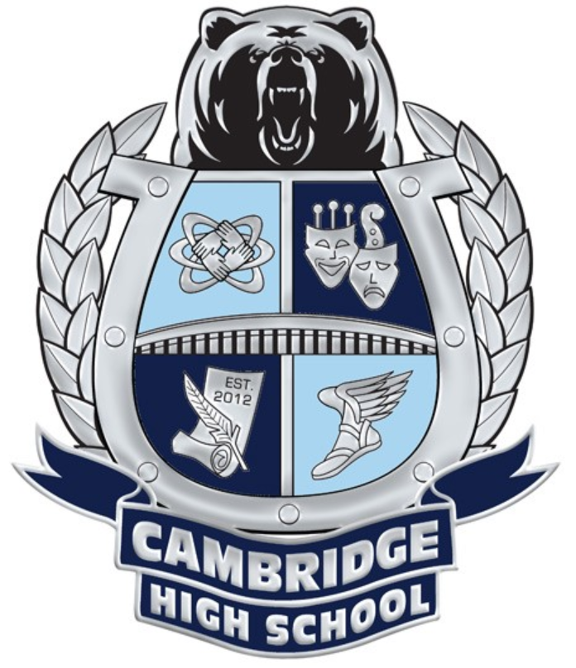
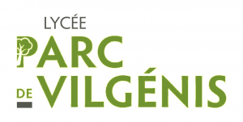
Cambridge High School French Exchange Itinerary (PROPOSED)
October 5-15, 2022
Lycée Parc de Vilgénis
80 rue de Versailles
91200 Massy, France
Vilgenis.fr
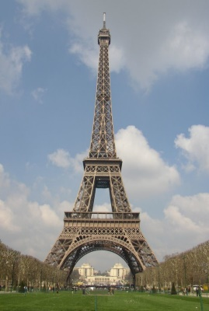
DAY 1: USA - FRANCE (Wednesday, Oct 5th) STUDENTS MISS DAY 1
- Fly out to Paris

DAY 2: PARIS - MASSY (Thursday, Oct 6th) STUDENTS MISS DAY 2
• Bienvenue en France! On arrival in Paris, your Terre des Langues representative will meet & greet you at the airport.
• Transfer by private motor coach to the French High School in Massy (South of Paris)
• Upon arrival meet your host family and enjoy your first dinner with your French family.

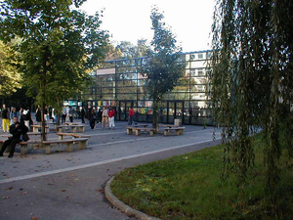
DAY 3: DAY AT THE LYCÉE VILGÉNIS (Friday, Oct 7th) STUDENTS MISS DAY 3
- Attend a variety of classes
- Eat lunch in the school cafeteria
- Participate in a tour of the school and scavenger hunt

DAYS 4 to 5: Saturday & Sunday, Oct 8th & 9th)
- Weekend with your French (participate in family life or see sites they propose)
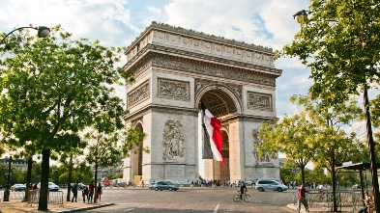
DAY 6: SCHOOL & EXCURSION TO PARIS (Monday, Oct 10th) NO SCHOOL
• Take a commuter train to Paris
• Once in Paris, you will visit the heart of the capital
• Visit the Arc de Triomphe and the Musée Rodin
• Return to Massy for dinner & night with your host family

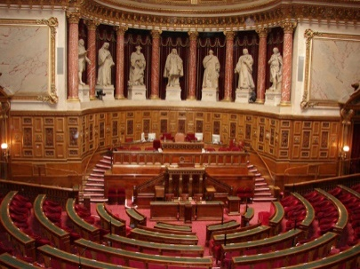
DAY 7: EXCURSION TO PARIS (Tuesday, Oct 11th) PD DAY
• Take a commuter train to Paris.
- Take a guided tour of the Senate in English
- See the beautiful Jardin du Luxembourg
- Eat lunch at an authentic Crêperie
- Walk around the Quartier Latin
• Return to Massy for dinner & night with your host family.
DAY 8: DAY EXCURSION TO PARIS (Wednesday, Oct 12th) TEACHER WORK DAY
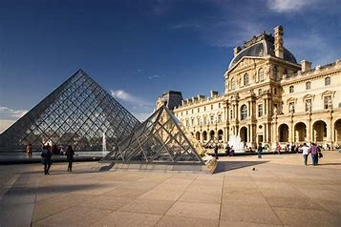
• Take a commuter train to Paris.
• Enter the Musée du Louvre for a guided visit. The Louvre in Paris is the world’s best-known, biggest, and busiest museum. Its famous collection of art and antiquities includes the Mona Lisa but also 35,000 works of art on display in 300 rooms.
• In the afternoon, you will board a glass-topped Bateau Mouche and enjoy a cruise on the Seine River. Discover all the magic of the banks of the Seine, where the most prestigious monuments that mark the French history have pride of place.
• Return to Massy for dinner & night with your host family.

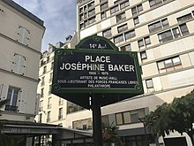
DAY 9: EXCURSION TO PARIS (Thursday, Oct 13th) STUDENTS MISS DAY 4
• Take a commuter train to Paris.
• Take a tour of important sites of African-Americans in Paris
- Walk along the Seine river and shop at the bouquiniste stands.
- Afternoon with Vilgénis students for rugby lessons and scrimmage.
• Return to Massy for dinner & night with host family.

DAY 10: DAY EXCURSION TO VERSAILLES (Friday, Oct 14th) STUDENTS MISS DAY 5
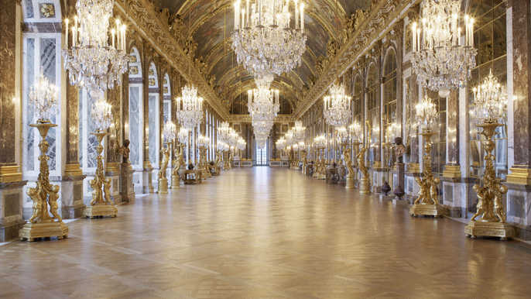
• Board a train to the Versailles Palace, the extravagant Palace built for the Sun King. Louis XIV’s palatial compound and spectacular gardens still wow visitors today just as they did during a period when nobles filled the halls, hoping for a glimpse of the king himself.
- Enter the Château for a private guided tour of King Louis XVI’s apartments
- Visit the rest of the chateau, including the Hall of Mirrors
- Explore the elegantly landscaped gardens.
- Return to Massy by train for dinner & night with host family.

DAY 11: DEPART (Saturday, Oct 15th)
- Transfer to airport by private motor coach for return flight home TOTAL STUDENT ABSENCES: 5 DAYS

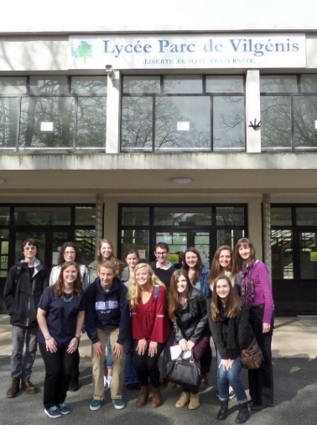
À bientôt et bon voyage!

